

Case Study:
Simulation of CPU Scheduling Algorithms

Operating Systems
Due: May 15, 2026

Submitted by:
Sayco, Hanszelle B.
BSCS - 3A
Ma’am Jo Anne Cura

1. Introduction
In any multi-programmed operating system, the CPU is one of the most limited and valuable resources available. Since multiple processes are often competing for CPU time simultaneously, the OS needs a way to decide which process gets to run, and for how long. This is what CPU scheduling is all about, it determines the order and duration of process execution from the ready queue, with the end goal of maximizing CPU utilization while keeping things fair and efficient for all running processes.

This case study was done to design and actually implement a working simulation of several CPU Scheduling Algorithms. Rather than just reading about how these algorithms work in theory, the goal here was to build a program that runs them and produces real outputs, a Gantt chart showing the execution timeline, and computed metrics like Waiting Time (WT) and Turnaround Time (TAT) for each process. By doing this, it becomes much easier to see and compare how each algorithm behaves under different conditions.

The specific objectives of this program are:
This project focuses on the implementation and comparative analysis of six core CPU scheduling algorithms: First-Come, First-Served (FCFS), Non-Preemptive Shortest Job First (SJF), Preemptive Shortest Remaining Time (SRT), Round Robin, Priority Scheduling, and a hybrid Priority with Round Robin approach. By accepting dynamic user inputs such as arrival times, burst times, priorities, and time quanta, the system simulates real-world processing scenarios to generate visual Gantt charts and calculate critical performance metrics, including Wait Time (WT) and Turnaround Time (TAT). Ultimately, the objective is to evaluate the practical efficiency and behavioral differences between preemptive and non-preemptive scheduling strategies through empirical data and average performance outcomes.

2. Body

2.1 Implementation Overview
To practically evaluate these theoretical concepts, a Python-based simulator was developed to process dynamic user inputs such as arrival times, burst times, priorities, and time quanta across both preemptive and non-preemptive environments. The system's architecture relies on a centralized Process object to track state variables (like remaining execution time for context switching) and a global simulation clock that continuously evaluates a dynamic ready queue. As this clock advances, the selected scheduling algorithm dictates CPU allocation, allowing the program to accurately log execution timelines into visual Gantt charts while automatically computing definitive performance metrics, including Waiting Time (WT) and Turnaround Time (TAT), for comparative analysis.

Repository Link: https://github.com/Hansz101/Sayco_OS_CaseStudy_CPU_Scheduling.git

# CPU Scheduling Simulation Program
# Algorithms included: FCFS, SJF, SRT, RR, Priority, Priority with RR

class Process:
def __init__(self, pid, arrival, burst, priority=0):
self.pid = pid
self.arrival = arrival
self.burst = burst
self.rem = burst # Remaining time for preemptive algorithms
self.priority = priority
self.wt = 0
self.tat = 0
self.finish_time = 0

def print_metrics(processes):
total_wt, total_tat = 0, 0
print("\n-------------------------------------------")
print("PID\tWT\tTAT")
for p in processes:
print(f"{p.pid}\t{p.wt}\t{p.tat}")
total_wt += p.wt
total_tat += p.tat
print(f"\nAverage WT: {total_wt/len(processes):.2f}")
print(f"Average TAT: {total_tat/len(processes):.2f}")
print("-------------------------------------------\n")

def fcfs(processes):
print("\n=== FCFS Scheduling ===")
processes.sort(key=lambda x: x.arrival)
time = 0
gantt = []
for p in processes:
if time < p.arrival:
time = p.arrival
start = time
time += p.burst
p.finish_time = time
p.tat = p.finish_time - p.arrival
p.wt = p.tat - p.burst
gantt.append(f"| {p.pid} ({start}-{time}) ")
print("Gantt Chart:", "".join(gantt) + "|")
print_metrics(processes)

def sjf_non_preemptive(processes):
print("\n=== SJF (Non-Preemptive) ===")
processes.sort(key=lambda x: x.arrival)
time = 0
completed = 0
n = len(processes)
gantt = []

while completed != n:
available = [p for p in processes if p.arrival <= time and p.finish_time == 0]
if not available:
time += 1
continue
available.sort(key=lambda x: x.burst)
p = available[0]
start = time
time += p.burst
p.finish_time = time
p.tat = p.finish_time - p.arrival
p.wt = p.tat - p.burst
completed += 1
gantt.append(f"| {p.pid} ({start}-{time}) ")

print("Gantt Chart:", "".join(gantt) + "|")
print_metrics(processes)

def srt_preemptive(processes):
print("\n=== Shortest Remaining Time (Preemptive) ===")
for p in processes: p.rem = p.burst
processes.sort(key=lambda x: x.arrival)
time = 0
completed = 0
n = len(processes)
gantt = []
last_pid = None
start_time = 0

while completed != n:
available = [p for p in processes if p.arrival <= time and p.rem > 0]

if not available:
if last_pid is not None:
gantt.append(f"| {last_pid} ({start_time}-{time}) ")
last_pid = None
time += 1
continue

available.sort(key=lambda x: x.rem)
p = available[0]

if last_pid != p.pid:
if last_pid is not None:
gantt.append(f"| {last_pid} ({start_time}-{time}) ")
last_pid = p.pid
start_time = time

p.rem -= 1
time += 1

if p.rem == 0:
p.finish_time = time
p.tat = p.finish_time - p.arrival
p.wt = p.tat - p.burst
completed += 1

if last_pid is not None:
gantt.append(f"| {last_pid} ({start_time}-{time}) ")

print("Gantt Chart:", "".join(gantt) + "|")
print_metrics(processes)

def round_robin(processes, tq):
print(f"\n=== Round Robin (TQ={tq}) ===")
time = 0
queue = []
completed = 0
n = len(processes)
gantt = []

for p in processes: p.rem = p.burst
processes.sort(key=lambda x: x.arrival)
i = 0
if processes:
queue.append(processes[i])
i += 1

while completed != n:
if not queue:
time += 1
while i < n and processes[i].arrival <= time:
queue.append(processes[i])
i += 1
continue

p = queue.pop(0)
start = time
run_time = min(p.rem, tq)
time += run_time
p.rem -= run_time
gantt.append(f"| {p.pid} ({start}-{time}) ")

while i < n and processes[i].arrival <= time:
queue.append(processes[i])
i += 1

if p.rem > 0:
queue.append(p)
else:
p.finish_time = time
p.tat = p.finish_time - p.arrival
p.wt = p.tat - p.burst
completed += 1

print("Gantt Chart:", "".join(gantt) + "|")
print_metrics(processes)

def priority_non_preemptive(processes):
print("\n=== Priority Scheduling (Non-Preemptive) ===")
processes.sort(key=lambda x: x.arrival)
time = 0
completed = 0
n = len(processes)
gantt = []

while completed != n:
available = [p for p in processes if p.arrival <= time and p.finish_time == 0]
if not available:
time += 1
continue
available.sort(key=lambda x: x.priority)
p = available[0]
start = time
time += p.burst
p.finish_time = time
p.tat = p.finish_time - p.arrival
p.wt = p.tat - p.burst
completed += 1
gantt.append(f"| {p.pid} ({start}-{time}) ")

print("Gantt Chart:", "".join(gantt) + "|")
print_metrics(processes)

def priority_with_rr(processes, tq):
print(f"\n=== Priority Scheduling with RR (TQ={tq}) ===")
for p in processes: p.rem = p.burst
processes.sort(key=lambda x: x.arrival)
time = 0
completed = 0
n = len(processes)
gantt = []
queue = []
i = 0

while completed != n:
while i < n and processes[i].arrival <= time:
queue.append(processes[i])
i += 1

if not queue:
time += 1
continue

highest_pri = min(p.priority for p in queue)
candidates = [p for p in queue if p.priority == highest_pri]

p = candidates[0]
queue.remove(p)

start = time
run_time = min(p.rem, tq)
time += run_time
p.rem -= run_time
gantt.append(f"| {p.pid} ({start}-{time}) ")

while i < n and processes[i].arrival <= time:
queue.append(processes[i])
i += 1

if p.rem > 0:
queue.append(p)
else:
p.finish_time = time
p.tat = p.finish_time - p.arrival
p.wt = p.tat - p.burst
completed += 1

print("Gantt Chart:", "".join(gantt) + "|")
print_metrics(processes)

def main():
while True:
print("\n--- CPU Scheduling Simulator ---")
print("1. FCFS")
print("2. SJF (Non-Preemptive)")
print("3. SRT (Preemptive SJF)")
print("4. Round Robin")
print("5. Priority (Non-Preemptive)")
print("6. Priority with Round Robin")
print("7. Exit")

choice = input("Select an algorithm (1-7): ")
if choice == '7':
break

n = int(input("Enter number of processes: "))
processes = []
for i in range(n):
pid = f"P{i+1}"
arr = int(input(f"Enter Arrival Time for {pid}: "))
burst = int(input(f"Enter Burst Time for {pid}: "))
pri = 0
if choice in ['5', '6']:
pri = int(input(f"Enter Priority for {pid} (lower = higher priority): "))
processes.append(Process(pid, arr, burst, pri))

if choice == '1':
fcfs(processes)
elif choice == '2':
sjf_non_preemptive(processes)
elif choice == '3':
srt_preemptive(processes)
elif choice == '4':
tq = int(input("Enter Time Quantum: "))
round_robin(processes, tq)
elif choice == '5':
priority_non_preemptive(processes)
elif choice == '6':
tq = int(input("Enter Time Quantum: "))
priority_with_rr(processes, tq)
else:
print("Invalid choice. Please try again.")

if __name__ == "__main__":
main()

2.2 First-Come, First-Served (FCFS)

- How it works: Processes are executed strictly in the order they arrive in the ready queue. The first process to arrive gets the CPU first, and it runs until completion before the next one starts.
- Type: Non-Preemptive
- Advantages: Very simple to implement and easy to understand. There's no complex sorting or decision-making involved.
- Limitations: Suffers from the "Convoy Effect", if a process with a very long burst time arrives first, all the shorter processes behind it are forced to wait, which results in poor average waiting times overall.

Test Case 1
Input: P1 (Arrival: 0, Burst: 5), P2 (Arrival: 1, Burst: 3), P3 (Arrival: 2, Burst: 1)
Gantt Chart:
P1 | P2 | P3
0–5 | 5–8 | 8–9

Computed Metrics:
Process | Arrival Time | Burst Time | Waiting Time (WT) | Turnaround Time (TAT)
P1 | 0 | 5 | 0 | 5
P2 | 1 | 3 | 4 | 7
P3 | 2 | 1 | 6 | 7
Average |  |  | 3.33 | 6.33

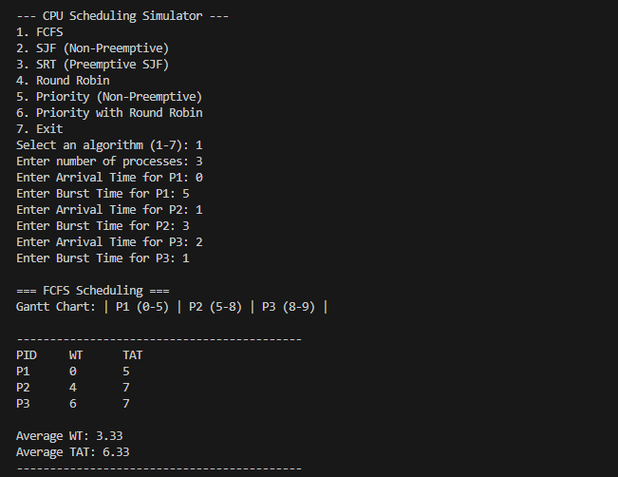

Test Case 2
Input: P1 (Arrival: 0, Burst: 2), P2 (Arrival: 1, Burst: 4), P3 (Arrival: 2, Burst: 6)

Gantt Chart:
P1 | P2 | P3
0–2 | 2–6 | 6–12

Computed Metrics:
Process | Arrival Time | Burst Time | Waiting Time (WT) | Turnaround Time (TAT)
P1 | 0 | 2 | 0 | 2
P2 | 1 | 4 | 1 | 5
P3 | 2 | 6 | 4 | 10
Average |  |  | 1.67 | 5.67
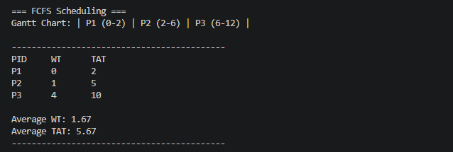

2.3 Shortest Job First (SJF) – Non-Preemptive
Operating as a non-preemptive algorithm, Shortest Job First (SJF) functions by selecting the available process with the smallest burst time at every decision point and running it to completion without interruption. Its primary advantage is its theoretical efficiency, as it is designed to produce the minimum possible average waiting time for any given batch of processes, provided the burst times are known in advance. However, the algorithm faces significant practical limitations; it is susceptible to "starvation," where longer processes remain in the queue indefinitely if a steady stream of shorter processes continues to arrive. Furthermore, its reliance on pre-defined burst times makes it difficult to implement in environments where process durations are unpredictable.

Test Case 1
Input: P1 (Arrival: 0, Burst: 6), P2 (Arrival: 1, Burst: 4), P3 (Arrival: 2, Burst: 2)

Gantt Chart:
P1 | P3 | P2
0–6 | 6–8 | 8–12

Computed Metrics:
Process | Arrival Time | Burst Time | Waiting Time (WT) | Turnaround Time (TAT)
P1 | 0 | 6 | 0 | 6
P2 | 1 | 4 | 7 | 11
P3 | 2 | 2 | 4 | 6
Average |  |  | 3.67 | 7.67

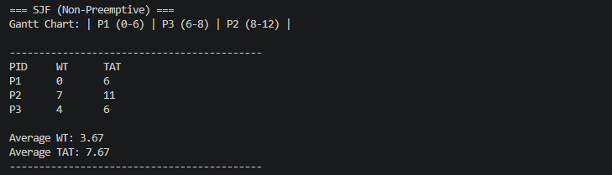

Test Case 2
Input: P1 (Arrival: 0, Burst: 5), P2 (Arrival: 2, Burst: 3), P3 (Arrival: 4, Burst: 1)

Gantt Chart:
P1 | P3 | P2
0–5 | 5–6 | 6–9

Computed Metrics:
Process | Arrival Time | Burst Time | Waiting Time (WT) | Turnaround Time (TAT)
P1 | 0 | 5 | 0 | 5
P2 | 2 | 3 | 4 | 7
P3 | 4 | 1 | 1 | 2
Average |  |  | 1.67 | 4.67

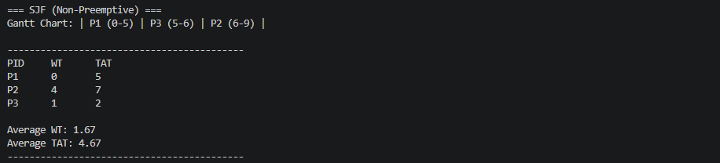

2.4 Shortest Remaining Time (SRT) – Preemptive
As the preemptive counterpart to Shortest Job First (SJF), the Shortest Remaining Time (SRT) algorithm constantly evaluates the CPU queue to ensure the most efficient process is running. Whenever a new process enters the ready queue, the scheduler compares its burst time against the remaining time of the active process; if the newcomer is shorter, the current process is preempted and the new one takes over. This approach is highly responsive and typically yields superior average waiting times in dynamic environments where processes arrive at different intervals. However, this efficiency comes at a cost, as frequent context switching introduces significant system overhead. Additionally, SRT still faces the risk of process starvation for longer tasks and requires increased implementation complexity to track and update remaining burst times in real-time.

Test Case 1
Input: P1 (Arrival: 0, Burst: 6), P2 (Arrival: 1, Burst: 4), P3 (Arrival: 2, Burst: 2)

Gantt Chart:
P1 | P2 | P3 | P2 | P1
0–1 | 1–2 | 2–4 | 4–7 | 7–12

Computed Metrics:
Process | Arrival Time | Burst Time | Waiting Time (WT) | Turnaround Time (TAT)
P1 | 0 | 6 | 6 | 12
P2 | 1 | 4 | 2 | 6
P3 | 2 | 2 | 0 | 2
Average |  |  | 2.67 | 6.67

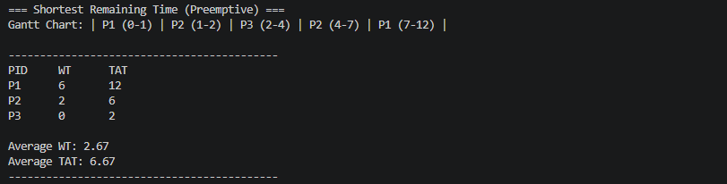

Test Case 2
Input: P1 (Arrival: 0, Burst: 5), P2 (Arrival: 1, Burst: 2), P3 (Arrival: 3, Burst: 4)

Gantt Chart:
P1 | P2 | P1 | P3
0–1 | 1–3 | 3–7 | 7–11

Computed Metrics:
Process | Arrival Time | Burst Time | Waiting Time (WT) | Turnaround Time (TAT)
P1 | 0 | 5 | 2 | 7
P2 | 1 | 2 | 0 | 2
P3 | 3 | 4 | 4 | 8
Average |  |  | 2.00 | 5.67

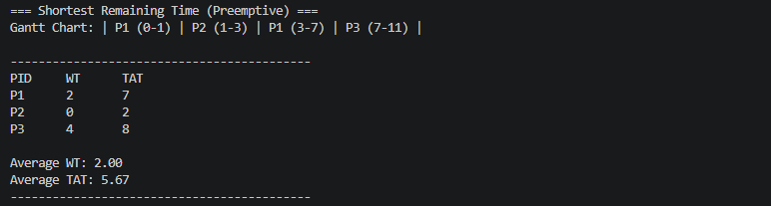

2.5 Round Robin (RR)
Round Robin is a preemptive scheduling algorithm designed for fairness and responsiveness, especially in time-sharing systems. It operates by assigning each process a fixed time interval known as a Time Quantum (TQ). The CPU cycles through the ready queue, granting each process one TQ of execution time; if a process does not finish within its allotted slice, it is preempted and moved to the back of the queue to await its next turn. This ensures that no single task can monopolize the CPU, providing excellent response times for all users. However, the algorithm's efficiency is heavily dependent on the size of the Time Quantum. If the TQ is too small, the system suffers from excessive context-switching overhead, whereas an overly large TQ causes the algorithm to degrade into First-Come, First-Served (FCFS) behavior, potentially leading to long wait times for shorter processes.

Test Case 1 (Time Quantum = 2)
Input: P1 (Arrival: 0, Burst: 5), P2 (Arrival: 1, Burst: 3), P3 (Arrival: 2, Burst: 1)

Gantt Chart:
P1 | P2 | P3 | P1 | P2 | P1
0–2 | 2–4 | 4–5 | 5–7 | 7–8 | 8–9

Computed Metrics:
Process | Arrival Time | Burst Time | Waiting Time (WT) | Turnaround Time (TAT)
P1 | 0 | 5 | 4 | 9
P2 | 1 | 3 | 4 | 7
P3 | 2 | 1 | 2 | 3
Average |  |  | 3.33 | 6.33

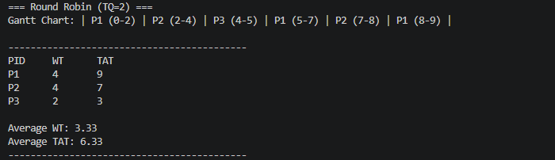

Test Case 2 (Time Quantum = 2)
Input: P1 (Arrival: 0, Burst: 4), P2 (Arrival: 0, Burst: 3), P3 (Arrival: 0, Burst: 2)

Gantt Chart:
P1 | P2 | P3 | P1 | P2
0–2 | 2–4 | 4–6 | 6–8 | 8–9

Computed Metrics:
Process | Arrival Time | Burst Time | Waiting Time (WT) | Turnaround Time (TAT)
P1 | 0 | 4 | 4 | 8
P2 | 0 | 3 | 6 | 9
P3 | 0 | 2 | 4 | 6
Average |  |  | 4.67 | 7.67

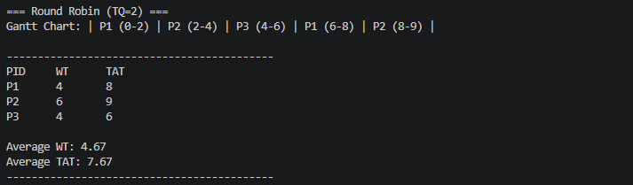

2.6 Priority Scheduling (Non-Preemptive)
Non-Preemptive Priority Scheduling operates by assigning a numerical priority value to every process, where a lower number typically signifies a higher priority (e.g., priority 1 precedes priority 3). Whenever the CPU becomes idle, the scheduler selects the highest-priority process from the ready queue and executes it to completion without interruption. This method provides the operating system with significant control, ensuring that critical system tasks are prioritized over less urgent background jobs. However, the primary drawback is the risk of "starvation," as low-priority processes may remain in the queue indefinitely if higher-priority tasks continue to arrive. While "aging" a technique that gradually increases a process's priority based on its wait time is a common solution to this issue, it is often omitted in basic implementations for the sake of simplicity.

Test Case 1
Input: P1 (Arrival: 0, Burst: 4, Priority: 3), P2 (Arrival: 1, Burst: 3, Priority: 1), P3 (Arrival: 2, Burst: 2, Priority: 2)

Gantt Chart:
P1 | P2 | P3
0–4 | 4–7 | 7–9

Computed Metrics:
Process | Arrival Time | Burst Time | Priority | Waiting Time (WT) | Turnaround Time (TAT)
P1 | 0 | 4 | 3 | 0 | 4
P2 | 1 | 3 | 1 | 3 | 6
P3 | 2 | 2 | 2 | 5 | 7
Average |  |  |  | 2.67 | 5.67

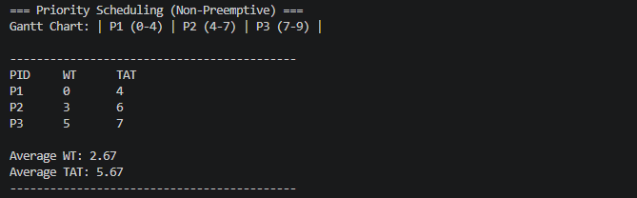

Test Case 2
Input: P1 (Arrival: 0, Burst: 3, Priority: 2), P2 (Arrival: 1, Burst: 5, Priority: 3), P3 (Arrival: 2, Burst: 2, Priority: 1)

Gantt Chart:
P1 | P3 | P2
0–3 | 3–5 | 5–10

Computed Metrics:
Process | Arrival Time | Burst Time | Priority | Waiting Time (WT) | Turnaround Time (TAT)
P1 | 0 | 3 | 2 | 0 | 3
P2 | 1 | 5 | 3 | 4 | 9
P3 | 2 | 2 | 1 | 1 | 3
Average |  |  |  | 1.67 | 5.00

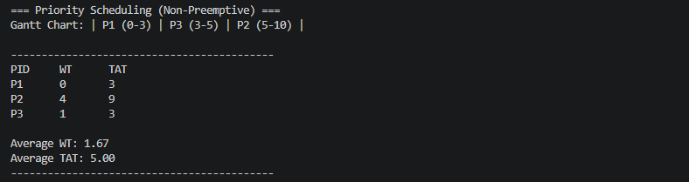

2.7 Priority Scheduling with Round Robin
Priority with Round Robin is a preemptive, hybrid scheduling algorithm that combines the strict hierarchy of priority scheduling with the equitable time-sharing of Round Robin. In this approach, processes are first categorized by their assigned priority levels, ensuring that the highest-priority group always receives CPU access first. However, if multiple processes share the exact same priority level, the scheduler employs Round Robin logic allocating a fixed Time Quantum to each process to distribute CPU time fairly among them. This dual-layered strategy effectively balances the need to execute urgent tasks immediately while preventing any single process from monopolizing the CPU when competing with peers of equal importance. Despite these advantages, this hybrid method introduces significant implementation complexity and system overhead, as the operating system must simultaneously manage multiple priority queues and actively track Round Robin time slices within each priority group.

Test Case 1 (Time Quantum = 2)
Input: P1 (Arrival: 0, Burst: 4, Priority: 1), P2 (Arrival: 0, Burst: 5, Priority: 1), P3 (Arrival: 0, Burst: 2, Priority: 2)

Gantt Chart:
P1 | P2 | P1 | P2 | P2 | P3
0–2 | 2–4 | 4–6 | 6–8 | 8–9 | 9–11

Computed Metrics:
Process | Arrival Time | Burst Time | Priority | Waiting Time (WT) | Turnaround Time (TAT)
P1 | 0 | 4 | 1 | 2 | 6
P2 | 0 | 5 | 1 | 4 | 9
P3 | 0 | 2 | 2 | 9 | 11
Average |  |  |  | 5.00 | 8.67

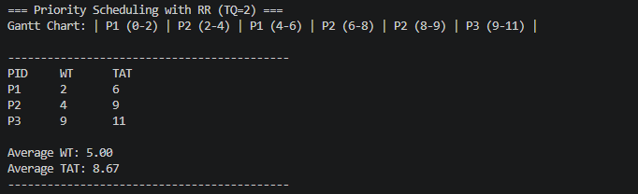

Test Case 2 (Time Quantum = 2)
Input: P1 (Arrival: 0, Burst: 3, Priority: 2), P2 (Arrival: 0, Burst: 3, Priority: 2), P3 (Arrival: 0, Burst: 4, Priority: 1)

Gantt Chart:
P3 | P3 | P1 | P2 | P1 | P2
0–2 | 2–4 | 4–6 | 6–8 | 8–9 | 9–10

Computed Metrics:
Process | Arrival Time | Burst Time | Priority | Waiting Time (WT) | Turnaround Time (TAT)
P1 | 0 | 3 | 2 | 6 | 9
P2 | 0 | 3 | 2 | 7 | 10
P3 | 0 | 4 | 1 | 0 | 4
Average |  |  |  | 4.33 | 7.67

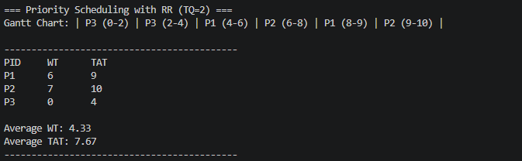

2.8 Comparison of Scheduling Algorithms
The table below summarizes how each algorithm performed across key metrics in the test cases above:

Algorithm | Type | Avg WT (TC1) | Avg TAT (TC1) | Starvation Risk | Complexity
FCFS | Non-Preemptive | 3.33 | 6.33 | None | Low
SJF | Non-Preemptive | 3.67 | 7.67 | High | Medium
SRT | Preemptive | 2.67 | 6.67 | High | Medium
Round Robin | Preemptive | 3.33 | 6.33 | None | Medium
Priority | Non-Preemptive | 2.67 | 5.67 | High | Medium
Priority + RR | Preemptive | 5.00 | 8.67 | Medium | High

3. Summary / Takeaways
Working on this case study gave me a much more hands-on understanding of something that I thought I already understood from the lectures. The biggest takeaway for me is that there really is no single "best" scheduling algorithm — each one makes trade-offs depending on what you're optimizing for.

From the simulations, I noticed that SJF consistently gave the best average waiting times on paper, but only because all burst times were known in advance. In a real OS, you generally don't know how long a process will take, which makes pure SJF impractical. FCFS, while simple, really showed its weakness with the Convoy Effect — one long process at the front of the queue can drag everyone else's waiting time way up. The preemptive algorithms like SRT and RR handled dynamic arrivals much better, though they come with the trade-off of higher context-switching overhead.

In terms of fairness, Round Robin stood out. It may not always have the lowest average waiting time, but no process gets starved — every process gets a turn within a predictable time frame. Priority scheduling is powerful for real-world use (since not all processes are equally important), but without aging, it's a starvation risk. The Priority + Round Robin combination is a good middle ground, though it was also the most complex to reason through.

The most challenging part of the implementation was handling the preemptive algorithms — specifically making sure that waiting times were calculated correctly when processes got interrupted and resumed. Tracking remaining burst times and properly updating the clock required careful testing to get right. I ran several manual trace-throughs alongside the code output to verify that the Gantt charts and metrics matched.

Overall, this case study made it clearer why modern operating systems don't rely on any single algorithm. Real schedulers like the Linux CFS (Completely Fair Scheduler) or Windows' Multilevel Feedback Queue draw from several of these concepts and adapt dynamically based on process behavior. Understanding these building blocks first makes those advanced systems much easier to appreciate.

4. References
GeeksforGeeks. (2023). CPU Scheduling in Operating Systems. https://www.geeksforgeeks.org/cpu-scheduling-in-operating-systems/

Silberschatz, A., Galvin, P. B., & Gagne, G. (2018). Operating System Concepts (10th ed.). John Wiley & Sons.

Tanenbaum, A. S., & Bos, H. (2015). Modern Operating Systems (4th ed.). Pearson.

